# Code Smells

1. Duplicate Code

Found at src/main/java/org/jabref/model/entry/BibEntry.java





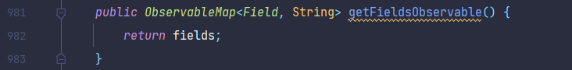

I consider this a “duplicate code” code smell since both methods, getFieldMap() and getFieldsObservable() end up returning exactly the same thing. To fix this, we could simply eliminate either method.

1. Long Method

Found at src/main/java/org/jabref/model/openoffice/ootext/OOTextIntoOO.java

This seems to be a “long method” code smell for several reasons. Firstly, the method is almost 200 lines long. Secondly, the method has several moving parts inside, which can easily be compartimentalized into separate methods. And finally, one can find several comments within the method attempting to explain what each part of it does, suggesting that the method is too complicated.

My proposal to mitigate this consists in taking the following switch statement, and placing it into a separate method:

However, the switch statement itself presents a problem, since it is 130 lines long. This leads us to our next code smell.

1. Switch Statements

The switch statement presented above has over 20 cases. While some cases are simple and have clear similarities between them, others are very long.

To fix this, I would first suggest creating a method to handle the recurring portion of code shown below:



This method would receive the formatStack, the expectEnd, the argument for the pushLayer() method, as well as the tagName. It would solve the code repetition seen throughout most of the switch cases. Next, the cases “p”, “oo:referenceToPageNumberOfReferenceMark” and “span” should be handled in separate methods. And finally, the last cases corresponding to closing tags can be merged into one case only, separated by commas, and the code inside the case should be moved into a separate method.

Gabriela Costa 58625